1. **Agenda:**
   1. Let’s push Docker images from local system to Docker Hub.
   2. Why?
   3. So that others team members can pull/download the image and use it.
   4. Even you may use it on different system in different environment (UAT, Test, Production)
2. The ideal approach:
   1. Push all our repositories into **Docker Hub**.
   2. **Public** Image: anyone can access.
   3. **Private**: Only those who are authorized.
3. 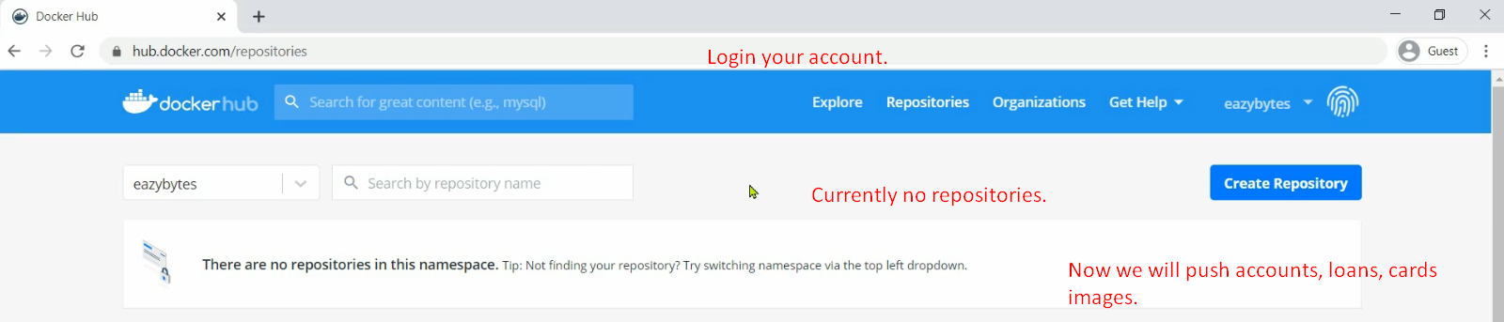
4. 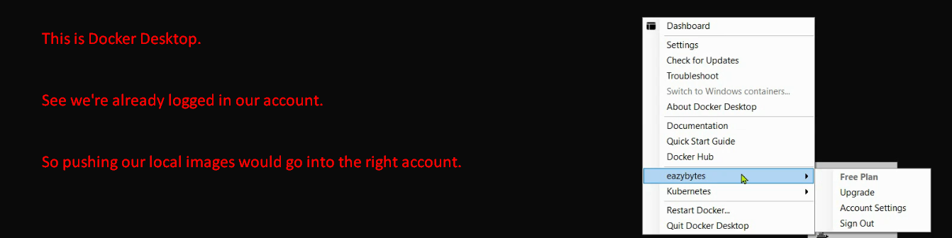  
   As we’re already logged in, so CLI is smart enough to detect the account under which you’re going to push your images.
5. 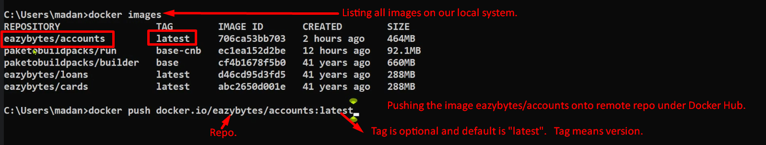
6. 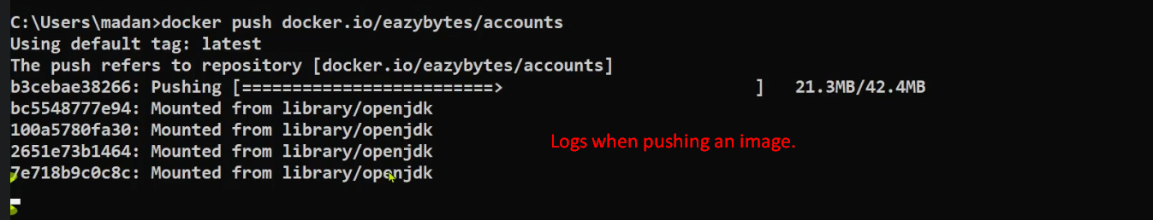
7. 
8. 
9. 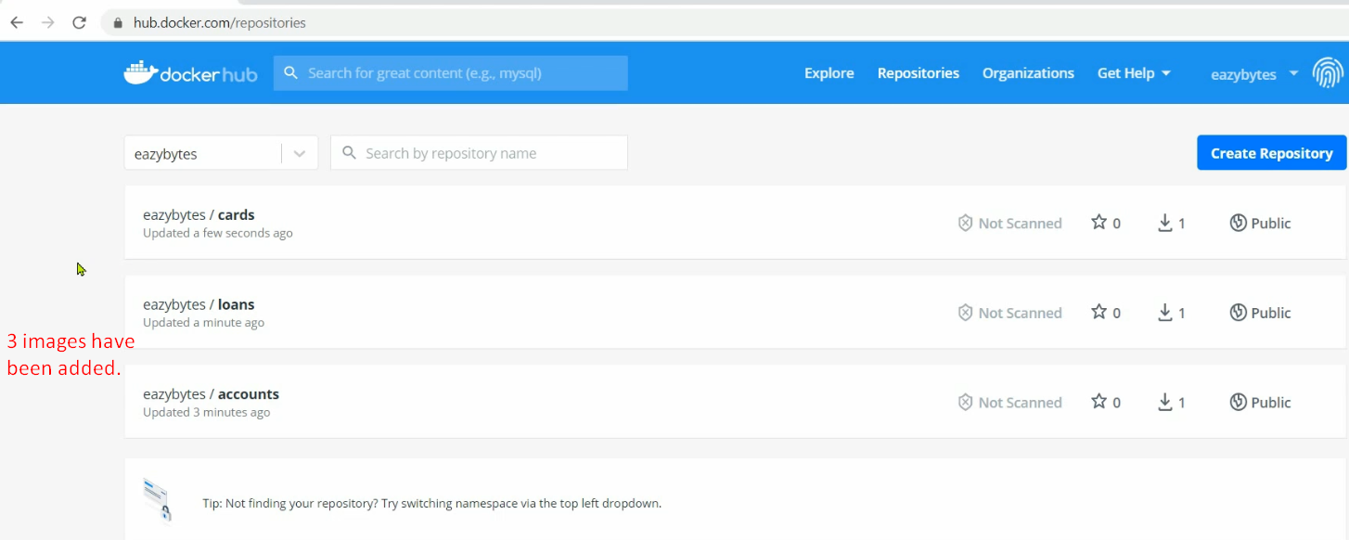
10. 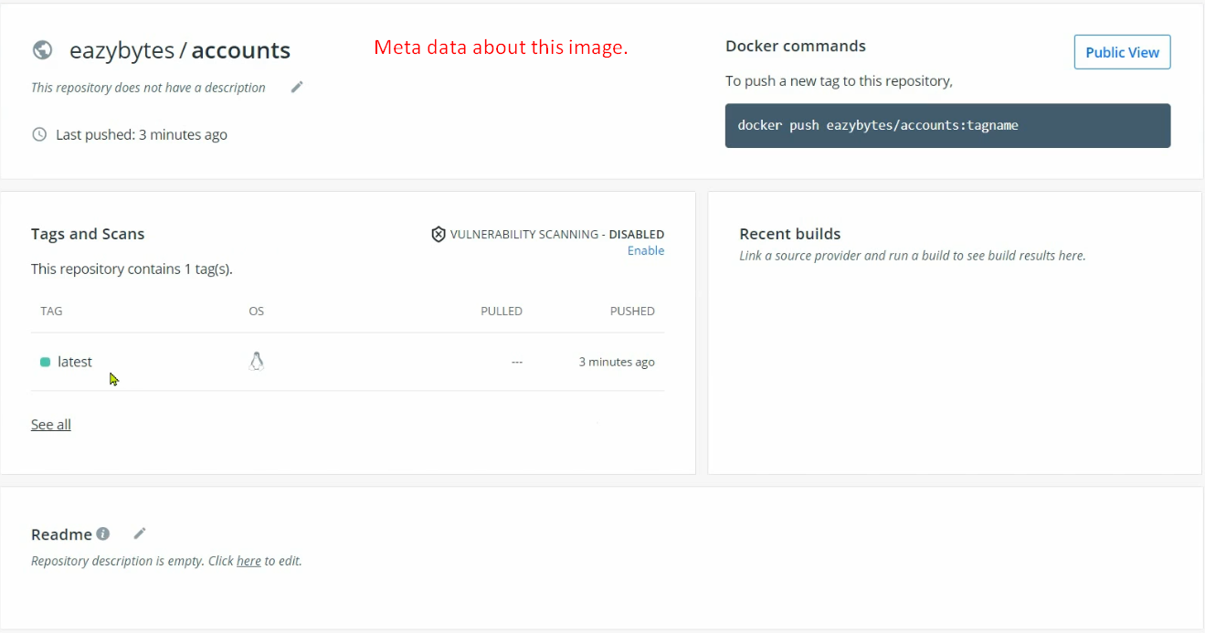
11. 